**WEEKLY MARKET ANALYSIS**

**Weekly Derivative Roundup for the Week Ended June 29, 2018**

**NIFTY FUTURES**  
Last week I saw hyper movement in NIFTY, from the opening it was moving up, from the opening of the week it was moving up continuously, on Monday it opened flat but from Tuesday I saw hyper buying in NIFTY, On Wednesday it made its weekly high of 10873.00 This week I saw continuous buying in NIFTY, in weekly candle stick it was taking support of its 14 day’s EMA on Friday I saw major move in NIFTY it made its weekly low of 10736 and closed at 10818.65 In weekly candle stick its structure is looking bullish and in daily candle stick its taking support of its 14 day’s EMA also, I am expecting from this level it will move up and will make new weekly high.

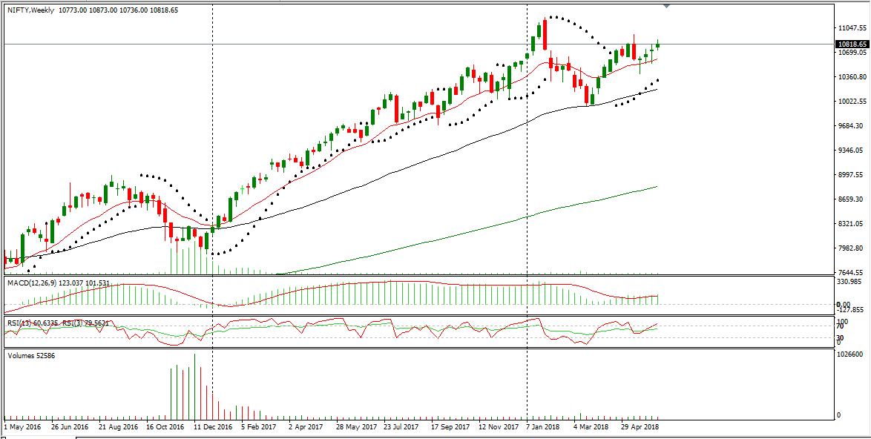

|  |  |  |  |  |  |
| --- | --- | --- | --- | --- | --- |
| **INDEX** | **S2** | **S1** | **PP** | **R1** | **R2** |
| **CNX NIFTY** | 10675 | 10750 | 10810 | 10880 | 10945 |

**BANK NIFTY FUTURE**

Last week I saw hyper movement in NIFTY, from the opening it was moving up, from the opening of the week it was moving up continuously, on Monday it opened flat but from Tuesday I saw hyper buying in NIFTY, On Wednesday it made its weekly high of 10873.00 This week I saw continuous buying in NIFTY, in weekly candle stick it was taking support of its 14 day’s EMA on Friday I saw major move in NIFTY it made its weekly low of 26306.70 and closed at 26407.90.  
In weekly candle stick its structure is looking bullish and in daily candle stick its taking support of its 14 day’s EMA also, I am expecting from this level it will move up and will make new weekly high.

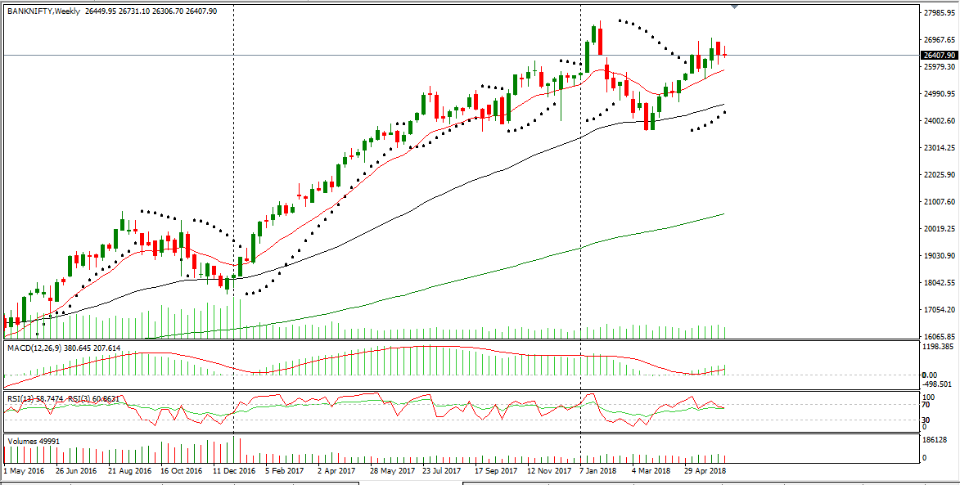

|  |  |  |  |  |  |
| --- | --- | --- | --- | --- | --- |
| **INDEX** | **S2** | **S1** | **PP** | **R1** | **R2** |
| **BANK NIFTY** | 26060 | 26235 | 26480 | 26660 | 26905 |

|  |  |  |  |  |  |
| --- | --- | --- | --- | --- | --- |
| **SCRIPS** | **S2** | **S1** | **PIVOT** | **R1** | **R2** |
|  |  |  |  |  |  |
| **ACC** | 1260 | 1279 | 1314 | 1333 | 1369 |
| **AXIS BANK** | 498 | 514 | 533 | 550 | 569 |
| **BAJAJ-AUTO** | 2805 | 2838 | 2886 | 2919 | 2967 |
| **BANK BARODA** | 125 | 128 | 133 | 136 | 141 |
| **BHEL** | 71 | 73 | 76 | 78 | 81 |
| **BHARTI AIRTEL** | 357 | 368 | 381 | 391 | 404 |
| **CIPLA** | 539 | 575 | 595 | 630 | 650 |
| **DLF** | 191 | 195 | 202 | 206 | 213 |
| **GAIL** | 325 | 330 | 338 | 343 | 351 |
| **HCE TECH** | 891 | 919 | 937 | 965 | 982 |
| **HDFC BANK** | 1998 | 2013 | 2038 | 2053 | 2078 |
| **HERO MOTOCO** | 3554 | 3619 | 3666 | 3731 | 3777 |
| **ICICI BANK** | 272 | 277 | 285 | 290 | 298 |
| **IDFC** | 49 | 48 | 50 | 51 | 52 |
| **INFY** | 1215 | 1252 | 1271 | 1308 | 1328 |
| **INDUSIND BANK** | 1864 | 1917 | 1948 | 2000 | 2031 |
| **LT** | 1296 | 1313 | 1341 | 1358 | 1386 |
| **M&M** | 888 | 897 | 912 | 920 | 935 |
| **PNB** | 86 | 88 | 91 | 93 | 97 |
| **RELIANCE** | 961 | 986 | 1004 | 1029 | 1047 |
| **SBIN** | 264 | 271 | 280 | 287 | 296 |
| **TATASTEEL** | 534 | 550 | 577 | 593 | 621 |
| **TCS** | 1706 | 1773 | 1810 | 1877 | 1914 |
| **TATAMOTORS** | 292 | 297 | 306 | 311 | 319 |
| **TECHM** | 675 | 692 | 707 | 724 | 739 |

**WEEKLY PIVOT LEVELS**

**Weekly FII’s Activity in F&O**

|  |  |  |  |  |
| --- | --- | --- | --- | --- |
| **DATE** | **NET VALUE** | **NET VALUE** | **NET VALUE** | **NET VALUE** |
| **INST.TYPE** | **INDEX FUTURES**  **Net Buy/Sell Value In**  **(Rs Cr.)** | **INDEX OPTIONS**  **Net Buy/Sell Value In**  **(Rs Cr.)** | **STOCK FUTURES**  **Net Buy/Sell Value In**  **(Rs Cr.)** | **STOCK OPTIONS**  **Net Buy/Sell Value In**  **(Rs Cr.)** |
| **14-June-2018** | -1303.79 | 4133.79 | -674.95 | -78.46 |
| **13-June-2018** | -297.48 | -244.78 | 88.33 | -125.56 |
| **12-June-2018** | -494.31 | -852.45 | 445.05 | -115.31 |
| **11-June-2018** | 472.39 | 632.60 | 86.42 | 61.94 |

**UPCOMING QUARTERLY RESULT**

**SECURITIES BAN THIS WEEEK**

|  |  |
| --- | --- |
| 18 -JUNE- 2018 | SPECTRA, FREDUN, STURDY |
| 19 -JUNE- 2018 | HMT |
| 20 -JUNE- 2018 | JBFIND, KWALITY, TRIDETOOL |
| 21 -JUNE- 2018 | KRRAIL |
| 22 -JUNE- 2018 | SUMEETINDS |

|  |  |
| --- | --- |
| 18 -JUNE- 2018 | JUSTDIAL |
| 18 -JUNE- 2018 | DHFL |
| 18 -JUNE- 2018 | JETAIRWAYS |
|  |  |
|  |  |
|  |  |

**WEEKLY GAINERS**

|  |  |  |  |
| --- | --- | --- | --- |
| **SCRIPS** | **CURRENT  PRICE** | **%CHANGE** | **PREVIOUS CLOSE** |
| **DRREDDY** | 2349.85 | 13.91% | 2062.90 |
| **LUPIN** | 913.2 | 12.73% | 810.05 |
| **CIPLA** | 611.60 | 9.28% | 559.65 |
| **SUNPHARMA** | 571.30 | 8.15% | 528.25 |
| **TCS** | 1840.05 | 5.32% | 1747.10 |
| **BAJFIN** | 2283.60 | 4.42% | 2186.85 |

**WEEKLY LOSERS**

|  |  |  |  |
| --- | --- | --- | --- |
| **SCRIPS** | **CURRENT  PRICE** | **%CHANGE** | **PREVIOUS CLOSE** |
| **TATA STEEL** | 566.00 | -5.75% | 600.50 |
| **ONGC** | 165.45 | -4.75% | 173.70 |
| **IOC** | 167.75 | -4.14% | 175.00 |
| **COALINDIA** | 279.05 | -3.74% | 289.90 |
| **NTPC** | 156.05 | -3.34% | 161.45 |
| **VEDL** | 238.60 | -3.13% | 246.30 |

**WEEKLY CALLS (CASH)**

|  |  |  |  |  |  |
| --- | --- | --- | --- | --- | --- |
| **SCRIPS** | **BUY/SELL** | **RANGE** | **TGT1** | **TGT2** | **SL** |
| **HDFC** | SELL | 1825-1830 | 1775 | 1675 | 1875 |
| **MOTHERSUMI** | SELL | 305-308 | 295 | 275 | 315 |
| **NTPC** | SELL | 155-154 | 145 | 125 | 165 |
| **ONGC** | BUY | 165-166 | 180 | 200 | 145 |
| **PTC** | BUY | 82-83 | 90 | 110 | 72 |
| **PNB** | BUY | 89-90 | 100 | 125 | 79 |
| **PIDILITIND** | BUY | 1075-1080 | 1100 | 1150 | 1050 |
| **RALLIS** | BUY | 200-201 | 210 | 225 | 190 |
| **RCOM** | BUY | 15-16 | 20 | 30 | 10 |
| **RPOWER** | BUY | 34-35 | 40 | 50 | 28 |
| **SOBHA** | BUY | 490-500 | 525 | 560 | 460 |
| **SBIN** | BUY | 275-277 | 300 | 375 | 250 |
| **TATA GLOBAL** | BUY | 270-272 | 300 | 350 | 250 |
| **TITAN** | BUY | 890-900 | 1010 | 1050 | 870 |
| **ZEEL** | SELL | 555-550 | 525 | 500 | 575 |
| **YES BANK** | BUY | 325-330 | 350 | 400 | 290 |
| **CEATLTD** | BUY | 1325-1335 | 1385 | 1485 | 1275 |
| **TATAELXSI** | BUY | 1300-1290 | 1350 | 1450 | 1250 |
| **M&MFIN** | SELL | 475-474 | 450 | 400 | 500 |
| **EQUITAS** | SELL | 150-151 | 140 | 125 | 160 |
| **GSFC** | BUY | 114-115 | 125 | 145 | 105 |
| **KSCL** | BUY | 550-560 | 580 | 660 | 520 |
| **MFSL** | BUY | 470-471 | 480 | 500 | 455 |
| **NBCC** | SELL | 85-86 | 75 | 60 | 95 |

**DISCLAIMER**

RESEARCH INFOTECH DO NOT RECEIVE ANY CONSIDERATION BY WAY OF REMUNERATION OR COMPENSATION OR IN ANY OTHER FORM WHATSOEVER, BY US OR ANY OF OUR ASSOCIATES OR SUBSIDIARIES FOR ANY DISTRIBUTION OR EXECUTION SERVICES IN RESPECT OF THE PRODUCTS OR SECURITIES FOR WHICH THE INVESTMENT ADVICE IS PROVIDED TO THE CLIENT.

RESEARCH INFOTECH DO NOT RECOMMEND A STOCK/COMMODITY BROKER. IF ANY STOCK/COMMODITY BROKER IS RECOMMENDED BY ANY OF OUR REPRESENTATIVE, WE DO NOT RECEIVE ANY CONSIDERATION BY WAY OF REMUNERATION OR COMPENSATION OR IN ANY OTHER FORM WHATSOEVER FROM STOCK/COMMODITY BROKER OR ANY OTHER INTERMEDIARY SO RECOMMENDED TO CLIENT.

TO ENSURE COMPLIANCE WITH THE INVESTMENT ADVISOR REGULATIONS 2013, WE HAVE RESOLVED THAT THE INVESTMENT ADVISOR AND ALL ITS REPRESENTATIVES WILL NOT MAKE ANY TRADES IN THE MARKET. WE ARE NOT ASSOCIATED IN ANY MANNER WITH ANY ISSUER OF PRODUCTS/ SECURITIES, THIS ENSURES THAT THERE IS NO ACTUAL OR POTENTIAL CONFLICTS OF INTEREST. THIS ALSO ENSURES THAT OBJECTIVITY OR INDEPENDENCE IN THE CARRYING ON OF INVESTMENT ADVISORY SERVICES IS NOT COMPROMISED. INVESTMENT IN STOCK/COMMODITY MARKETS IS SUBJECT TO MARKET RISK, THOUGH BEST ATTEMPTS ARE MADE FOR PREDICTING MARKETS, BUT NO SURETY OF RETURN OR ACCURACY OF ANY KIND IS GUARANTEED, WHILE THE PERFORMANCE SHEET OF VARIOUS PRODUCTS IS AVAILABLE BUT SHOULD NOT BE CONSIDERED AS A GUARANTEE FOR FUTURE PERFORMANCE OF THE PRODUCTS/SERVICES. CLIENTS ARE ADVISED TO CONSIDER ALL THE ADVICE AS JUST AN OPINION AND MAKE INVESTMENT DECISION ON THEIR OWN.

IN CASE OF CLIENTS SEEKING ADVICE ON ANY SPECIFIC POSITIONS ALREADY MADE BY THE CLIENT, WE WILL BE ABLE TO SUGGEST BEST POSSIBLE ACTION CONSIDERING OUR VIEW ON THE SECURITY OR PRODUCT. SUCH SUGGESTION UNDER ANY CIRCUMSTANCES SHALL BE CONSIDERED AS AN OPINION (NOT ADVICE) FROM OUR ORGANIZATION AND WE ADVISE CLIENT TO CONSIDER OUR OPINION AND NOT CONSULTANCY TO MAKE HIS/HER FINAL DECISION. WE ARE NOT LIABLE FOR ANY LOSSES WHATSOEVER CLIENT MAY INCUR IN ACCEPTING THIS OPINION.

CLIENT IS ALSO ADVISED TO TRADE ONLY IF TIPS SUIT HIS CURRENT RISK APPETITE AND RISK BEARING CAPACITY, ALL SUCH TIPS SHALL BE CONSIDERED AS A VIEW OR OPINION AND CLIENT SHALL ON HIS/HER DISCRETION DECIDE ACTUAL TRADES.

WE ARE NOT ASSOCIATED WITH ANY INTERMEDIARIES AND DO NOT RECOMMEND SERVICES OF ANY SPECIFIC INTERMEDIARIES.  
NO LITIGATIONS HAVE BEEN FILED AGAINST US SINCE THE INCORPORATION.

ALL THE TIPS WHICH ARE SUGGESTED BY US ARE COMMUNICATED IN WRITTEN, NO VERBAL COMMUNICATION FROM ANY OF THE EXECUTIVES OR OTHERWISE UNDER ANY CIRCUMSTANCES SHALL BE CONSIDERED AS ADVICE BY OUR ORGANIZATION.